Experiment No.: 8
Title: Access and Validate Form Using Events – Design a Gym Admission Form with Live Input Checks
Software/Tools Required: HTML5, CSS3, JavaScript, VS Code, Google Chrome
Theory: In JavaScript, form events such as input, change, blur, and submit are used to access and validate user input in real time. When a user types in a field, the input event fires, allowing immediate validation. For radio buttons, checkboxes, and dropdowns, the change event is used. The blur event validates a field when the user leaves it.Form validation ensures that data entered by the user follows specific rules, such as required fields, correct email format, valid mobile number, password strength, and matching passwords. By using JavaScript with DOM manipulation, we can display error or success messages dynamically and enable or disable the submit button based on overall validity. The submit event is used to prevent the default page reload and process the form only when all fields are valid.A gym admission form requires details like full name, email, mobile number, date of birth, gender, membership plan, password, address, and terms acceptance. Live input checks improve user experience by giving instant feedback and reducing invalid submissions
Output:
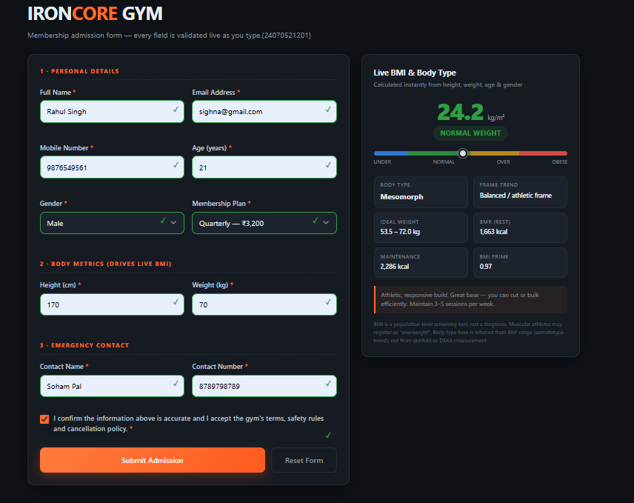

Result: A gym admission form was successfully designed using HTML5, CSS3, and JavaScript. Live input validation was implemented using JavaScript events such as input, change, blur, and submit. Each field was validated according to its rules, error messages were displayed dynamically, password strength was shown visually, and the submit button remained disabled until all inputs were valid. The form data was successfully accessed, validated, and managed.
Conclusion: Thus, JavaScript events can be effectively used to access and validate form data in real time. Live input checks provide immediate feedback to users, prevent invalid form submissions, and improve the overall usability and reliability of web forms such as a gym admission form.

